**CEE 526 Finite Elements for Engineers**

**Modeling Project 2-1**

Due Date: April 8th , 2016

Author: Michael Justice

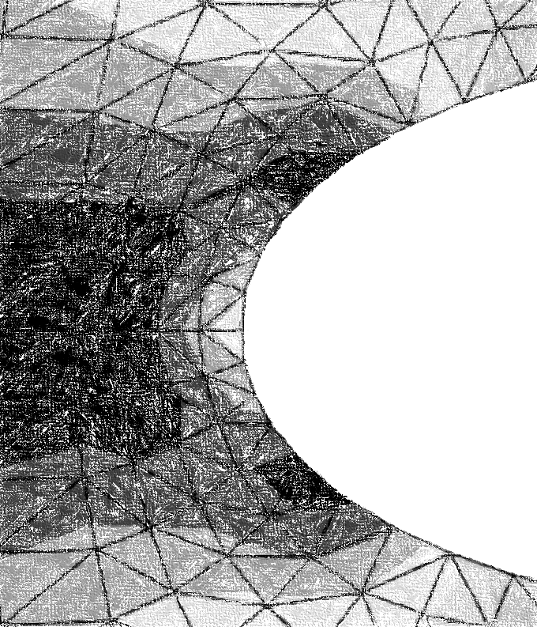

Table of Contents

Fireclay Column 4

Problem Description 4

Finite Element Model 5

Results (and Convergence Results) 6

Conclusions 9

References 10

Steel beam Under Torsion 11

Problem Description 11

Finite Element Model 12

Results (and Convergence Results) 13

Conclusions 16

References 17

List of Figures

Figure 1 – (Column ) Problem Figure 4

Figure 2 - (Column ) Model with Shown Boundary Conditions 5

Figure 3a – (Column ) Temperature distribution Using Q4 Elements 6

Figure 3b - (Column ) Temperature distribution Using T3 Elements 7

Figure 4 – (Column ) Heat Rate Convergence of Q4, T3 Elements 8

Figure 5 - (Column ) Heat Rate Throughout Column Section 9

Figure 6 - (Steel beam) Problem Figure 11

Figure 7- (Steel beam) Model with Shown Boundary Conditions and Loading 13

Figure 8 – (Steel beam) Model with Illustration of Maximum Shearing Stresses 13

Figure 9– (Steel beam) Stress Convergence for T3 Element 15

Figure 10 -– (Steel beam) Angle of Twist Convergence for T3 Element 16

List of Equations

**No table of Equations entries found.**

List of Tables

Table 1 – (Column ) Q4 Mesh Summary 7

Table 2– (Column ) T3 Mesh Summary 8

Table 3 - (Steel beam) T3 Mesh Summary 14

# Fireclay Column

## Problem Description

For this FEA (Finite Element Analysis) project, the goal was to a) determine the temperature distribution in the column and b) determine the heat rate at the airstream. These two tasks were accomplished using the FEA program Abaqus. The free (student) version of the program was used for this project. Figure 1 below is a sketch of the column.

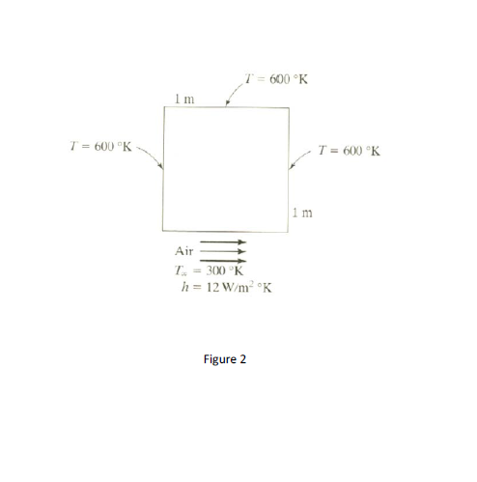

r +

z+

|  |
| --- |
| Figure 1 – (Column) Problem Figure |

The model is a fireclay column with an overall dimension 1m x 1m, with a convective heat transfer of 12 W/m^2-K at the bottom side. The fireclay column was insulated on all sides excluding the bottom at a constant temperature of 600 K. The bottom side was set at an ambient temperature of 300 K. The fireclay brick had a thermal conductivity of 1.0 W/m-K.

## Finite Element Model

The finite element model (FEM) was constructed using the student version of Abaqus. The limitation of the student version is that all models are limited to 1000 nodes or less. Therefore, only *linear* Q4 and T3 elements were used to stay under the 1000 node limit. These two element types alone were also chosen to ensure a proper systematic approach to yield an accurate result for the convergence analysis.

The model was created on the basis that the column underwent a steady-state response of heat transfer from the supported furnace. The model was assumed to be of the long body type (plane strain for thermal problems) since the column height is much larger than the cross-section dimensions. Below is a model (Figure 2) of the column illustrating the temperature boundary conditions around the edges and the heat transfer at the bottom edge.

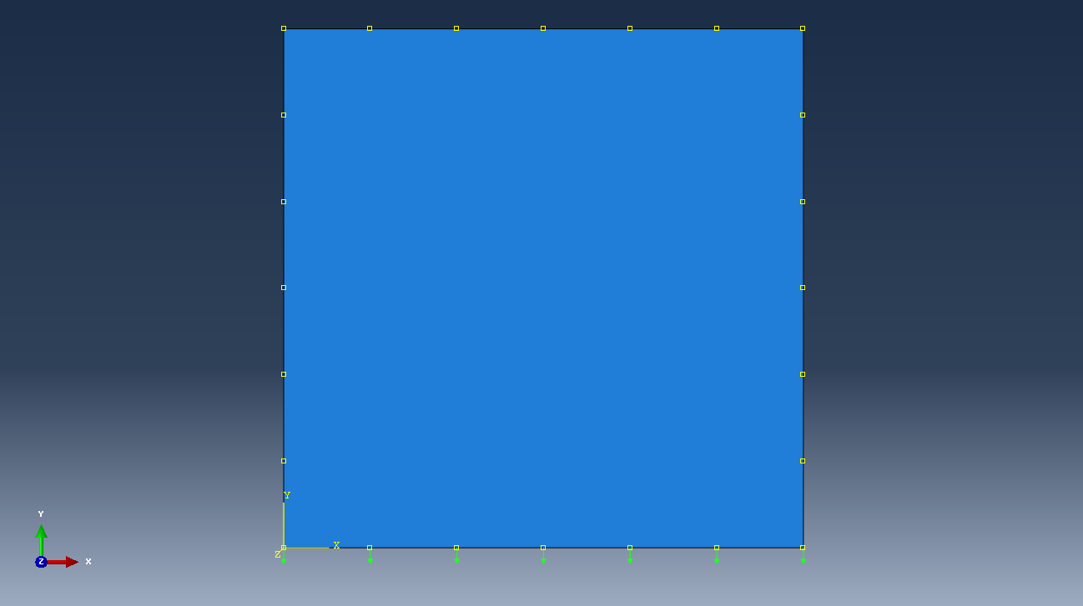

**Boundary Condition (Temperature)**

**Uniform Loading (Convective Heat Transfer)**

Figure 2 - (Column) Model with Shown Boundary Conditions

The loading was applied in such a way that the heat in the column is leaving the system through the bottom edge.

## Results (and Convergence Results)

The following figure is the temperature distribution of the model with Q4 elements (Figure 3).

`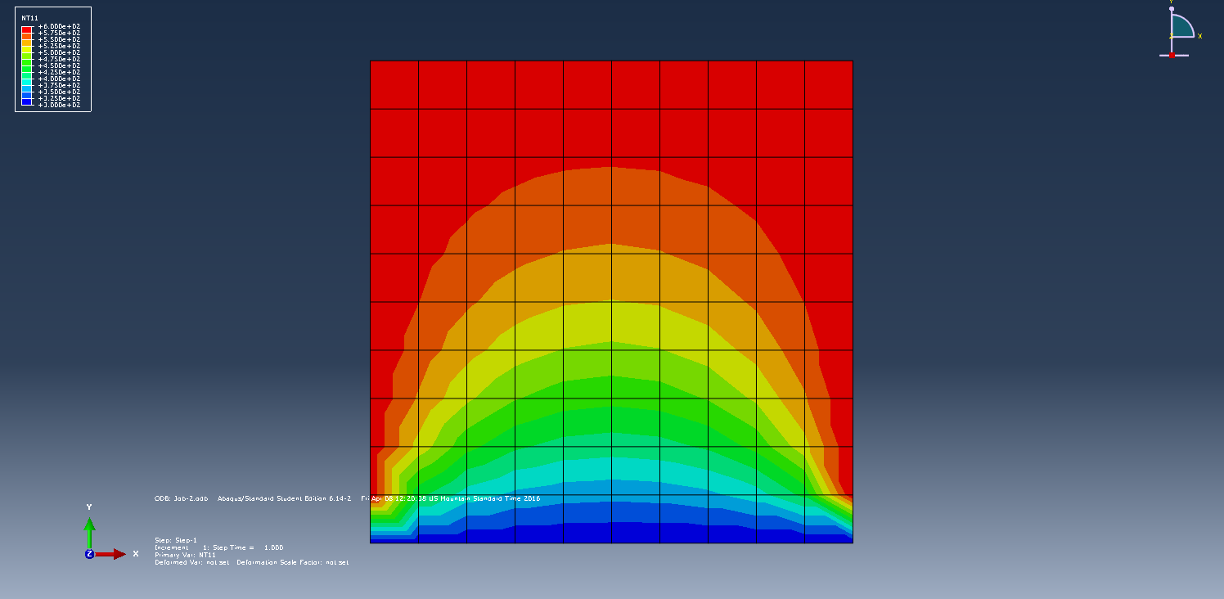

**300 K Temp**

**600 K Temp**

**600 K Temp**

**600 K Temp**

|  |
| --- |
| Figure 3a – (Column) Temperature Distribution Using Q4 Elements |

Note that the temperature distribution can clearly be checked in Figure 3, as the temperature is the same as that of the prescribed boundary conditions. Once can see that the temperature decreases going from the top of the cross-section to the bottom edge, where the convective heat transfer took place. The following figure (Figure 3b) illustrates the temperature distribution of the column with T3 elements.

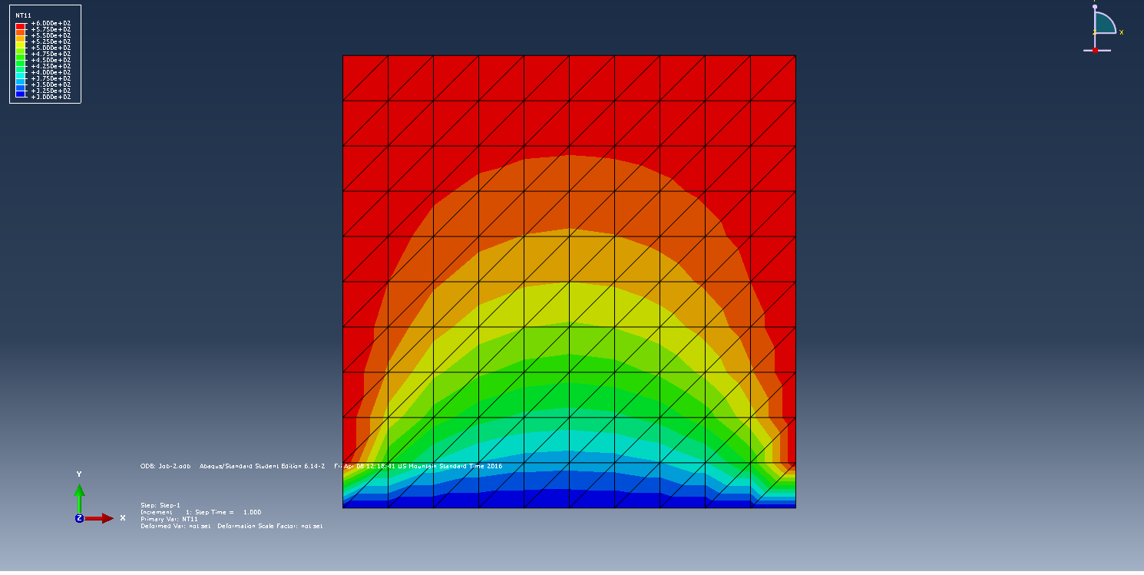

|  |
| --- |
|  |

Figure 3b - (Column) Temperature Distribution Using T3 Elements

Below is Table 1, which summarizes the finite element result for the Q4 model.

Table 1 – (Column) Q4 Mesh Summary

|  |  |  |  |
| --- | --- | --- | --- |
| **Model** | **Element Type** | **Number of Elements** | **Heat Rate (W) to Airstream** |
| Model 1 | Q4 | 25 | 946.6 |
| Model 2 | Q4 | 100 | 1959 |
| Model 3 | Q4 | 196 | 2545 |
| Model 4 | Q4 | 289 | 2585 |
| Model 5 | Q4 | 625 | 2615 |

From Table 1, it can be seen that the heat rate converges nicely with an increase in elements. Below is Table 2, which summarizes the finite element result for the T3 model.

Table 2– (Column) T3 Mesh Summary

|  |  |  |  |
| --- | --- | --- | --- |
| **Model** | **Element Type** | **Number of Elements** | **Heat Rate (W) to Airstream** |
| Model 1 | T3 | 50 | 986.2 |
| Model 2 | T3 | 200 | 1958 |
| Model 3 | T3 | 392 | 2539 |
| Model 4 | T3 | 578 | 2657 |
| Model 5 | T3 | 1250 | 2734 |

From Table 2, it can again be seen that the heat rate does indeed converge. Figure 4 below illustrates this convergence and compares the two element types.

|  |
| --- |
| Figure 4 – (Column) Heat Rate Convergence of Q4, T3 Elements |

From Figure 4, it can be seen that T3 elements converge at a higher heat rate value than the Q4 elements. It should be noted that the heat rate was computed by taking the average of the heat rate values at the bottom edge nodes. Figure 5 below illustrates the heat rate throughout the column cross-section.

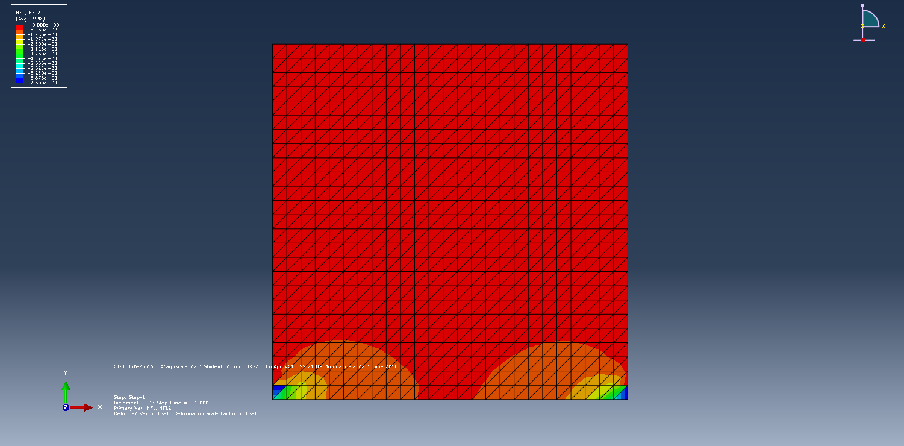

Figure 5 - (Column) Heat Rate Throughout Column Section

The elements at the bottom left and right have much larger heat rates than any of the other elements. This is due to the fact the temperature differential is greatest at those two points (600 K versus 300 K), which is essentially what drives the heat rate to change throughout the cross-section of the column.

## Conclusions

The following observations from the above results can be made about the finite element analysis of the fireclay column:

1. T3 elements converge faster than Q4 elements, or in other words, higher-order elements converge faster than lower-order elements.
2. The differential in temperature at the boundaries is what drives change in the heat rate of the system.
3. The temperature throughout the system decreases from any of the column edges towards the edge of lower temperature.
4. Maximum heat rate: 2734 W

## References

# Steel beam Under Torsion

## Problem Description

For this FEA (Finite Element Analysis) project, the goal was to a) determine the largest shearing stresses and locations, and b) the angle of twist. These two tasks were accomplished using the FEA program ASUTruss. Figure 6 below is a sketch of the steel beam.

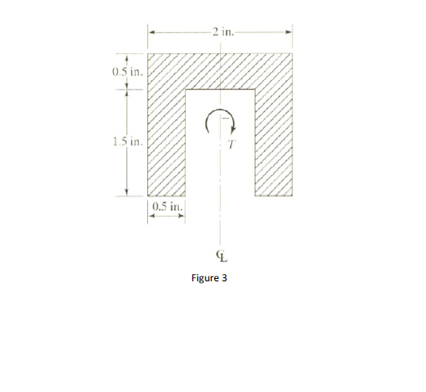

Z +

X +

Y+

|  |
| --- |
|  |

Figure 6 - (Steel beam) Problem Figure

The model is a steel beam with an overall dimension of 2” by 2”, with a cut-out measuring 1”x1.5”. An applied torque of 500 in-lbs was applied at the center of mass of the steel beam.

## Finite Element Model

The finite element model (FEM) was constructed using the ASUTruss program. The limitation of the ASUTruss program is that the program will only perform FEA analysis with T3 elements. Also, the program will only accept user-written input files, which are cumbersome to produce.

The model was created on the basis that the steel beam is made of elastic (linear), isotropic material with a shear modulus of 11.5e6 psi. The model was analyzed as a simple steel beam under torsional loading using the Airy’s Stress Function, as shown below:

Where on the boundary of the cross-section and the shear stress ,

And is the rate of twist.

In order for the program to run properly, the boundary of the cross-section must be laterally fixed. Figure 7 below illustrates one of the meshes for the beam, as well as the fixity conditions.

`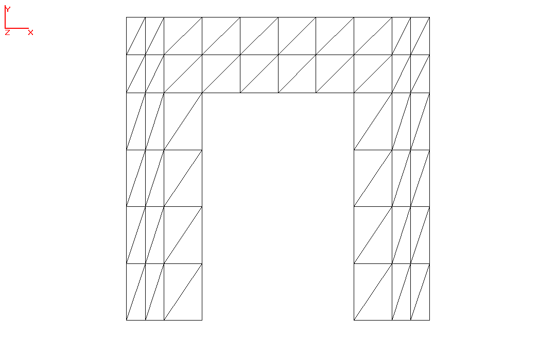

**Lateral Boundary Condition**

**500 in-lb Torque**

Figure 7- (Steel beam) Model with Shown Boundary Conditions and Loading

## Results (and Convergence Results)

Applying the torque load for the entire beam, the magnitude and location of the shear stress was determined, as shown below (Figure 8). Note the location of the maximum shearing stresses.



**Max tau_yz = 1141 psi**

**Max tau_xz = 768.1**

|  |
| --- |
|  |

Figure 8 – (Steel beam) Model with Illustration of Maximum Shearing Stresses

The maximum shearing stress in the yz plane is located as shown above, on the outside of the cross-section on the bottom left. An almost equal shearing stress of 1090 psi was located on the bottom right, symmetric to the 1141 psi stress. The maximum shearing stress in the xz plane is located on the top of the cross-section above the opening. Again, a similar shear stress value of 692 psi was found at the element symmetric to the maximum shear stress in the xz plane. It was expected that the maximum shearing stresses were located on the outer edges of the cross-section.

|  |
| --- |
|  |

The following table (Table 3) documents the number of elements and nodes used in each mesh analysis and the corresponding maximum stresses.

Table 3 - (Steel beam) T3 Mesh Summary

|  |  |  |  |  |  |  |
| --- | --- | --- | --- | --- | --- | --- |
| **Model** | **Element Type** | **Number of Elements** | **Number of Nodes** | **Max Shearing Stress XZ (psi)** | **Max Shearing Stress YZ (psi)** | **Angle of Twist (radians)** |
| Model 1 | T3 | 10 | 12 | 581.6 | 571.0 | 0.00011 |
| Model 2 | T3 | 16 | 18 | 724.0 | 724.0 | 0.00014 |
| Model 3 | T3 | 88 | 65 | 768.1 | 1141 | 0.00025 |

From Table 3 above, it can be seen that the shearing stresses converge from below, which is expected. Figure 9 below illustrates this convergence (and non-convergence) and compares the two shearing stresses.

Figure 9– (Steel beam) Stress Convergence for T3 Element

|  |
| --- |
|  |

From Figure 9, it can be seen that the shearing stresses are roughly the same for the first two meshes, and then the shearing stress along the YZ plane increases dramatically. If more meshes were created by constantly doubling the previous mesh’s element count, a smoother converging trend would be apparent for the shearing stress in the YZ plane. The data for the shearing stress along the XZ plane produces a smoother converging trend. From the plot of the angle of twist, it not apparent that the angle is converging. Producing a more refined mesh would yield a more acceptable result.

Figure 10 -– (Steel beam) Angle of Twist Convergence for T3 Element

## Conclusions

The following observations from the above results can be made about the finite element analysis of the steel beam:

1. Boundary conditions must be satisfied for the torsion problem. Lateral supports must be placed only at the boundary nodes. Nodes not on the boundary are to remain free of restraints.
2. A better refinement of the mesh size would yield better results for the shearing stress in YZ plane and angle of twist.
3. The maximum shearing stresses occur at the boundaries of the cross-section near corners.

## References